COMPLETING YOUR BPP (BUSINESS PERSONAL PROPERTY) RENDITION
The Texas Property Tax Code requires all personal property owned by a business for the purpose of producing an income to be reported, or rendered, to the appraisal district for valuation on an annual basis.
Things to Remember:
- The rendition is concerning personal property owned by the business on January 1st of the tax year. Not December 31st. Not January 2nd.
- Only tangible personal property such as furniture, fixtures, equipment, inventory, etc. are taxable. Intangibles such as cash, stocks, accounts receivable, and other paper assets are not taxable.
- The BPP rendition form is due by April 15th each year. Deadline extensions are available with a written request before the April 15th deadline of up to 30 days.
- The rendition forms mailed in mass by the appraisal district to the property owners may have some section 1 information pre-filled.
- The Appraisal District’s name will be Bastrop Central Appraisal District if your business personal property is physically located in Bastrop County.
- All fields are required unless otherwise indicated as ‘optional’.

Section 1: Business & Situs Information
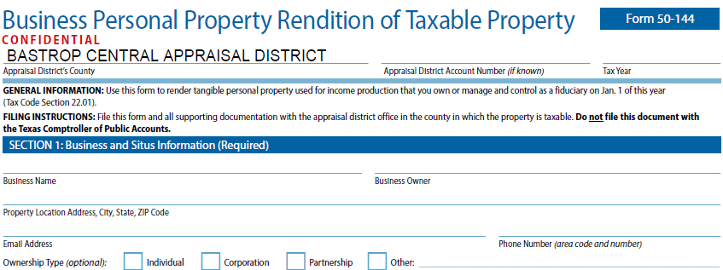
- At the very top, you will indicate the tax year for which the rendition applies.
- Business Name should be consistent with your Secretary of State filings.
- Business Owner should also be consistent with your Secretary of State filings.
- Property Location is the actual, physical location of the business personal property assets; also called the situs.
- Contact Email and Phone Number should be provided for easy communications.
- Ownership Type is optional, but helpful.

Section 2: Representation
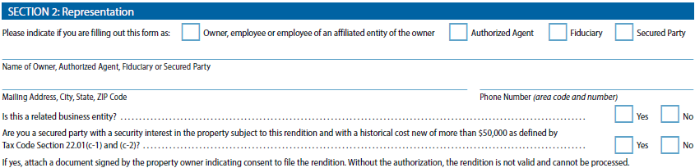
- Is this form being completed by the owner? Authorized agent? Fiduciary? Secured Party? Please indicate.
- If this form is being filed by the owner, repeat name and phone number.
- Provide the mailing address you would like communications to be sent; this does not have to be the same as the property location.
  - The mailing address indicated will be added to our records & any correspondence regarding your BPP account will be sent there.
- Indicate whether you are a related business entity. If you are not sure what this is, please consult your legal counsel.
  - Documentation is required if selecting “Yes”.
- Indicate whether you are a secured party with a security interest in the property. If you are not sure what this is, please consult your legal counsel.
  - Documentation is required if selecting “Yes”.

Section 3: Affirmation of Prior Year Rendition
- Was your prior year rendition filing the same as this year?
  - Your assets must be exactly the same as the previous year (no addition or disposal of assets).
- Check the box and add the prior tax year, if applicable.
  - If section 3 is applicable, no other schedules are required. please complete only Sections 1 through 6 of the rendition.
  - If your depreciated assets have no changes, but you have updated your inventory/supplies values, you may check this box AND update schedule B or C as applicable.

Section 4: Business Information
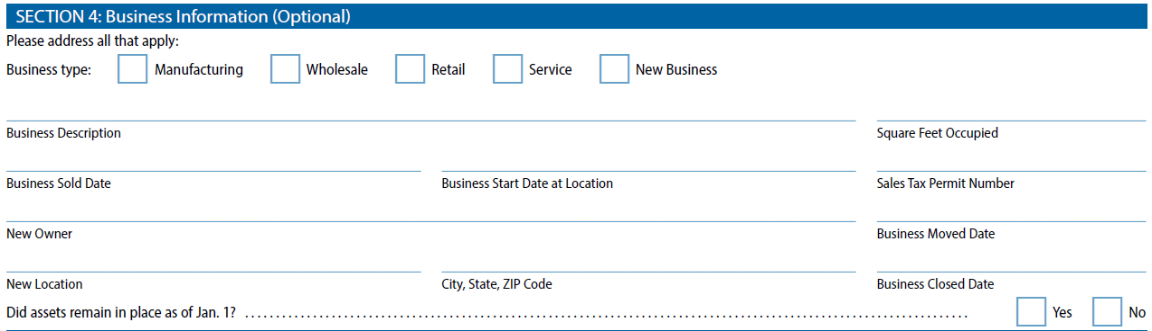
- Section 4 is optional, but the information provided is helpful for our appraisers and should be answered if applicable.
- What is your business type? Manufacturing? Wholesale? Retail? Service? New business? Check any that may apply.
- Business description will help us to properly classify your property.
- If you sold or moved your business, you will indicate so in the appropriate field. Failure to do so may result in erroneous tax statements and lengthy correction processes.
- Did assets remain in place as of Jan 1st? Or were they moved elsewhere?

Section 5: Market Value
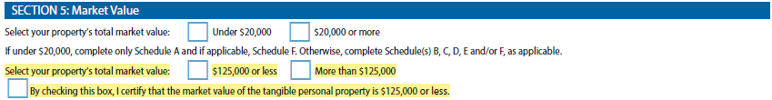
- What is the approximate total market value of your personal property? Under $20,00? Or over $20,000? Check one that applies.
  - The requirements for filing with property under $20,000 are different than for businesses valued over $20,000.
    - Under: Complete Schedules A and F, if applicable.
    - Over: Complete schedules B, C, D, E, and/or F, as applicable.
- What is the approximate total market value of your personal property? Under $125,000? Or over $125,000? Check one that applies. **Accounts that are under $125,000, please file an initial itemized rendition so we may update our records**
Section 6: Affirmation & Signature
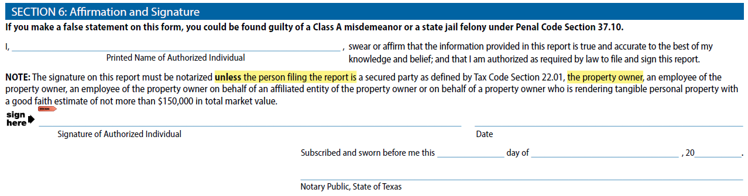
- The rendition must be signed by an authorized person to be valid.
- Printed Name of Authorized Individual (REQUIRED) – The person who either owns the property, is the agent, or holds fiduciary responsibility for the business & is filing this rendition.
- Signature of Authorized Individual (REQUIRED) – should be the same person as the Printed Name of the Authorized Individual.
- If the person filing and signing this report is the property owner or an employee of the property owner, they are not required to get this form notarized.
  - Note: If the person filing and signing this report is not the property owner, an employee of the property owner, an employee of a property owner signing on behalf of an affiliated entity of the property owner, or a secured party as defined by Tax Code Section 22.01, the signature must be notarized.
  - If the person filing and signing this report is an agent or entity filing on behalf of a property owner who is rendering tangible personal property only with a good faith estimate of more than $150,000 in total market value, the signature must be notarized.

Schedule A: Personal Property Valued Less Than $20,000
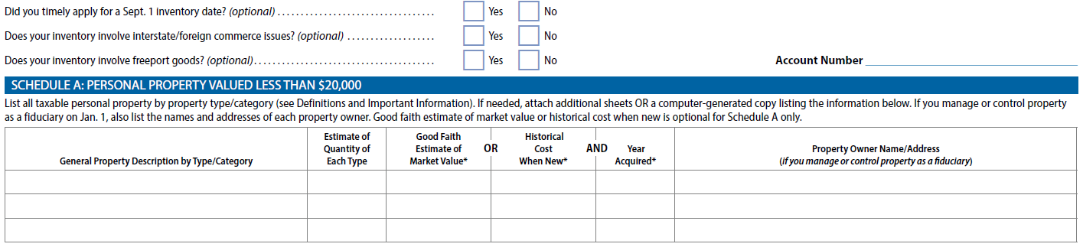
- The “optional” questions are useful to our appraisers and should be answered if applicable.
- This section is applicable to businesses with less than $20,000 in business personal property.
- Under Schedule A, list all general property descriptions by type/category. Categories may include furniture, fixtures, machinery, office equipment, computer equipment, signage, inventory, raw materials, supplies, and vehicles.
    - Note: if you list inventory, supplies, or vehicle assets here under Schedule A, you do not need to add them under Schedules B,C, or D respectively. We do not want to duplicate any assets.
  - Add an Estimate of quantity of each type of asset.
  - For each asset rendered, give either a good faith estimate of market value OR historical cost when new & the year acquired for the asset(s). This helps to accurately depreciate the items.
    - All assets rendered must have a value. Items received as gifts, or used assets where the historical cost or year acquired is not known should be listed with a good faith estimate of market value.
- Fiduciaries will need to list the property owner’s name and address in the last column.
- If more space is needed to list your assets, it is permissible to attach supplement pages, additional sheets, or excel spreadsheets with the required information as necessary.

Schedule B & Schedule C: Inventory, Raw Materials and Work in Progress / Supplies
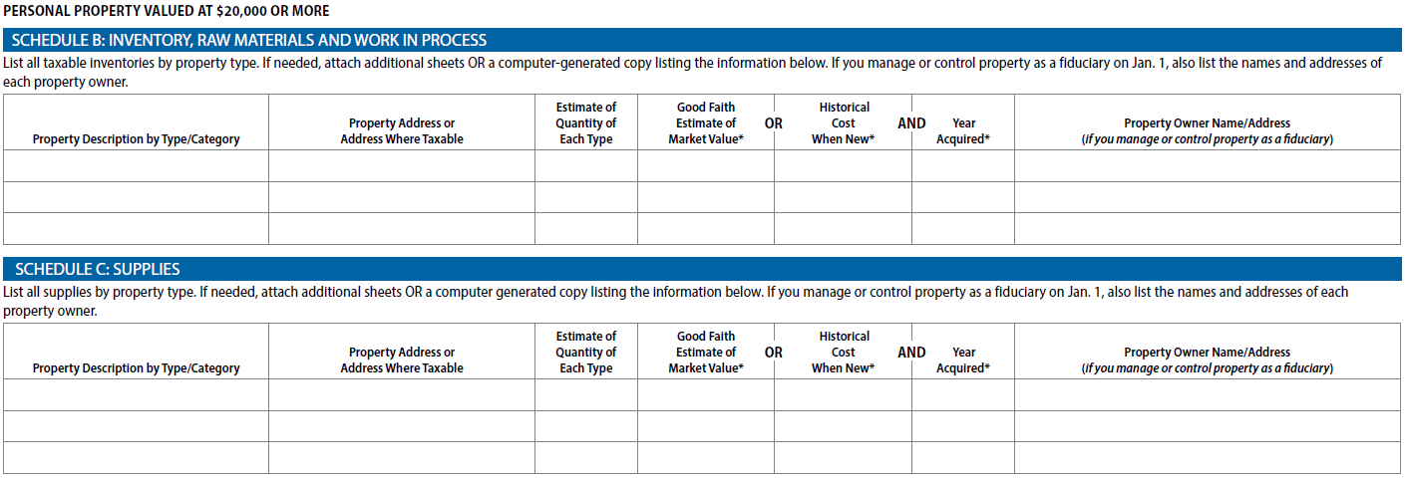
- Schedule B and C are required if the total value of all property exceeds $20,000 and own the type of property described in the heading.
  - Schedule B: list only inventory, raw materials, and work in progress.
  - Schedule C: list only supplies.
- Similar to Schedule A, Schedule B and C requires a list of the property type/category, an estimate of quantity for each type, and either a good faith estimate of market value OR historical cost when new & the year acquired for the asset(s).
  - All assets rendered must have a value. Items received as gifts, or used assets where the historical cost or year acquired is not known should be listed with a good faith estimate of market value.
  - If inventory, raw materials, work in progress, and/or supplies have already been listed under Schedule A, you do not need to add them under Schedules B or C.
- The taxable location, the property address, must also be listed for each type (if different from situs listed in Section 1).
- Fiduciaries will need to list the property owner’s name and address in the last column.
- If more space is needed to list your assets, it is permissible to attach supplement pages, additional sheets, or excel spreadsheets with the required information as necessary.

Schedule D: Vehicles and Trailers and Special Equipment
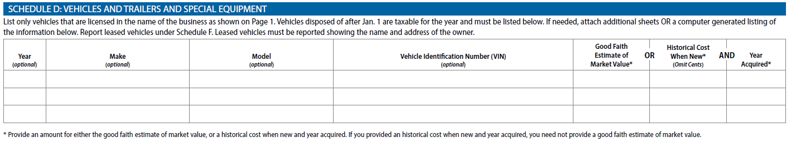
- Schedule D is required if the total value of all property exceeds $20,000 and you have property that fits the description under schedule D.
- The Year, Make, Model, and Vehicle Identification Number (VIN) of each vehicle is optional, but very useful to determine an accurate value & and ensure there is no double assessment.
- All vehicles rendered must include either a good faith estimate of market value OR historical cost when new & the year acquired for the asset(s).
  - All assets rendered must have a value. Items received as gifts, or used assets where the historical cost or year acquired is not known should be listed with a good faith estimate of market value
  - If vehicles have already been listed under Schedule A, you do not need to add them under Schedule D.
- If more space is needed to list your assets, it is permissible to attach supplement pages, additional sheets, or excel spreadsheets with the required information as necessary.

Schedule E: Furniture, Fixtures, Machinery, Equipment, Computers, POS, Other
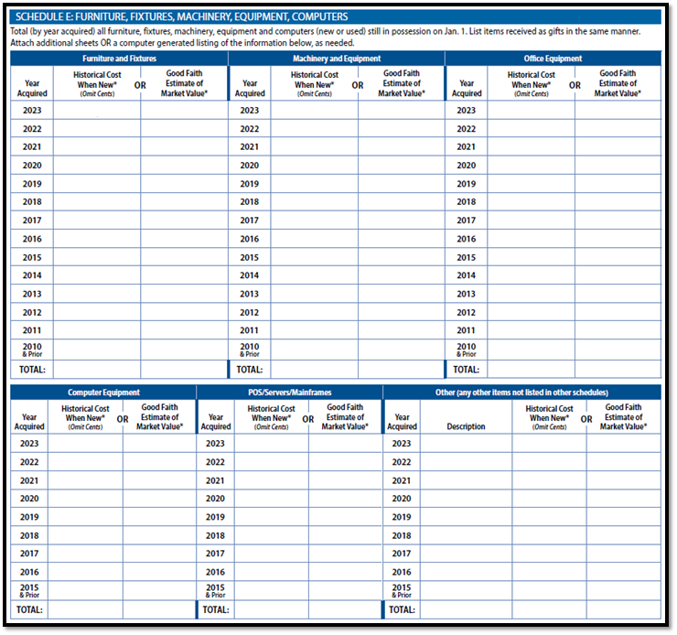
- This section breaks down the type of personal property by year acquired.
- In each section, you will provide the historical cost when new in the corresponding year acquired column OR a good faith estimate of market value per asset year.
  - All assets rendered must have a value. Items received as gifts, or used assets where the historical cost or year acquired is not known should be listed with a good faith estimate of market value.
  - Add Totals of Historical Cost or Good faith estimate of value for each column as applicable.
- There is also an “Other” column for any items owned by the business that were not listed in any other section. Could include signage.
- If more space is needed to list your assets, it is permissible to attach supplement pages, additional sheets, or excel spreadsheets with the required information as necessary.

Schedule F: Property Under Bailment, Lease, Consignment or Other Arrangement
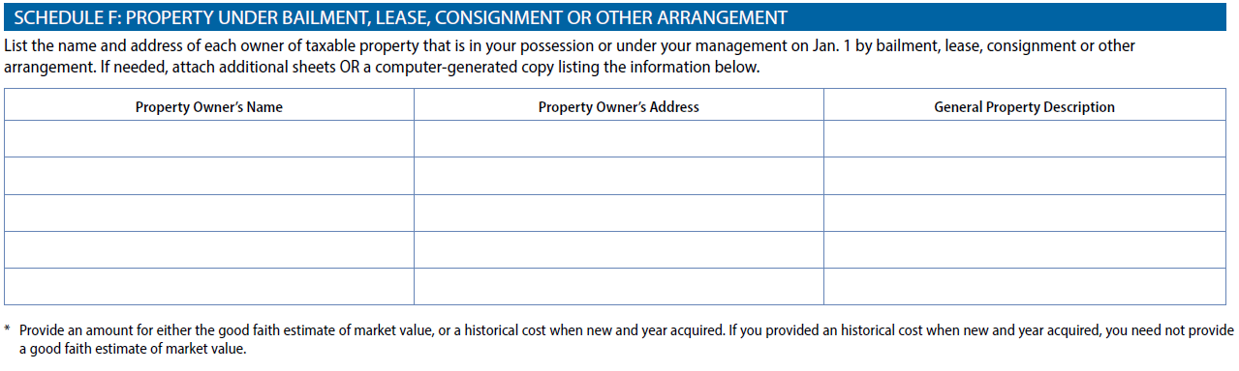
- This section should be completed by any business that possesses this type of property regardless of its total market value of all business personal property.
- If the business is using personal property assets that are under bailment, lease, consignment or other arrangement where the business is not responsible for the business personal property taxes, list the property here.
  - Include the owner’s name, address, and a general description of the property.
  - The district may ask the business owner to provide additional information, including lease agreements, rental prices, contracts, etc.
- If more space is needed to list your assets, it is permissible to attach supplement pages, additional sheets, or excel spreadsheets with the required information as necessary.

The last page of the rendition contains important information about deadlines, filing instructions, penalties, as well as definitions of common terms that will help users more fully understand the requirements.
Please contact the Bastrop CAD Business Personal Property department for any additional questions or clarifications.

